Dynamic Positioning

FAILURE MODE & EFFECTS ANALYSIS
MGC 2 (Other MGC units similar)
With: K-Pos DP21 - cJoy

This document is available under the Creative Commons Zero v1.0 license, as you downloaded and opened this document, it is acceptance of the license terms and conditions.
The main thrust of this license is to protect ALUCIANT in terms of warranty and liability, we do not warrant the templates nor accept liability for any of the templates and their use.
More details can be found on the ALUCIANT website at www.aluciant.com/cc0license/

Gyro Compasses & Motion Reference Units (MRU)
- General components/Layout

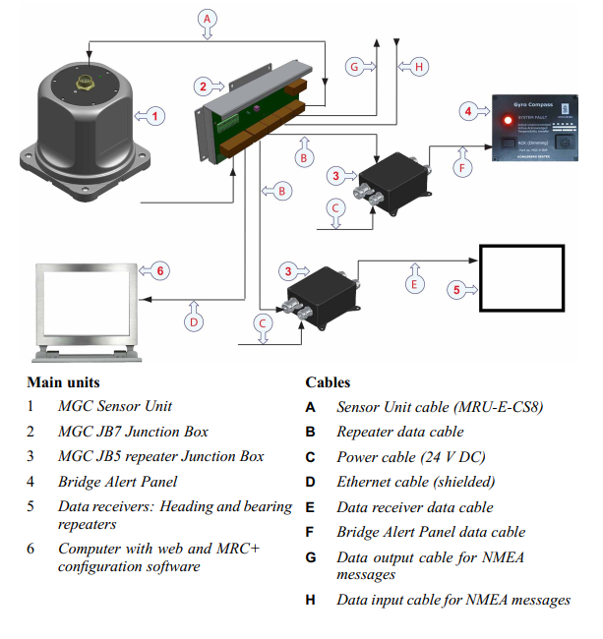
- Reference
- https://motionandgyro.com/
- https://www.kongsberg.com/contentassets/9c7466e11a8d427bb564104e1a0a9f4a/datasheet_mgc_r2gc.pdf
- Kongsberg JB7 interface
- Description, Location and Redundancy Concept
The vessel is fitted with three MGC R2 ring laser gyro compasses, all of which can be selected into DP and include pitch, roll and heave outputs. The DPO can enable all three into DP at any time. The DP system will then monitor and compare the selected gyros and motion inputs and alarm for heading / motion difference and power loss.
The gyro compasses are probably the most critical of the vessel reference sensors. Failure of the vessel heading reference can cause the vessel to oscillate or lose the heading altogether with serious consequences if the vessel is near an obstruction.
Each MGC Sensor Unit is connected via an MGC-E-CJB7 cable to an individual MGC JB7 Junction Box, which must be within 2 meters of the MGC Sensor Unit, the signals are then distributed to the required inputs to various equipment as required through the three ethernet ports, five COM ports, eight Replica Ports with three outputs each, and three relay & four analog ports.
Gyro 1 supplies the independent joystick system with a heading reference.
The MGC-R2 system can be operated as an Inertial Navigation System (INS) as well as a gyro compass with output of position and heading. Linear position and velocity measurements can then be output in up to four different points on the vessel. It is/is not not being operated in this mode for this installation.
The MGC is a strap-down based gyro compass including three Ring Laser Gyros and three linear accelerometers. The systems can operate in Attitude and Heading Reference System (AHRS) mode and Inertial Navigation mode. In the AHRS mode input of speed and latitude data is required. External time input is also required. In this mode the system will output heading, roll, pitch and heave. In the Inertial Navigation mode the output of latitude, longitude, height and time. PPS from a GNSS receiver is required. In this mode the unit will output heading, roll, pitch, heave and position.
Various reference systems such as DGNSS and HiPAP use accurately measured angles relative to the hull for their inputs to DP. The MRU input to DP is used to correct the DGNSS signals taking into consideration the angle of the hull, fore and aft, and port and starboard, relative to the horizontal. The importance of the MRU data increases as the weather worsens and ship movements become more severe.
Each MGC is alarmed at the DP Console for pitch/roll/heave difference and loss of power.
Failure of one MGC will cause the units rejection by the DP system; information output would be maintained using the healthy units.
The gyro compasses/MRUs are located as follows:
- No. 1 MGC – [LOCATION].
- No. 2 MGC – [LOCATION].
- No. 3 MGC – [LOCATION].
Power supplies for the gyro compasses/MRUs are as follows:
- No. 1 MGC – [Breaker No.]
- No. 2 MGC – [Breaker No.]
- No. 3 MGC – [Breaker No.]
- Configuration for DP
All three MGC’s should be selected into the DP system for both heading and MRU solutions. It is the operator’s decision which should be used as the preference, with an understanding of power supplies and other equipment with MGC feeds.
- Failure Modes & Effects of the MGC Units for heading and motion solutions
Significant failure modes of the gyro compasses are as follows:
- MGC Power Supply Failure:
This would cause alarms to sound on the K-Pos OS for loss of gyro and MRU solutions. The faulty MGC would be automatically deselected, and the two remaining MGC units would be used. The DP system would continue functioning with just two MGC’s; however, no voting would take place.
- Gyro giving an Incorrect Reading:
During DP operations all three gyros should be in use. Should one of the three gyro readings deviate beyond a pre-defined limit from the others (usually around 2°) then the DPC-2 will reject the faulty gyro from DP after three erroneous readings are received. The DP will then continue to use two healthy gyros as reference. Should a further gyro deviate from the heading then a “difference alarm” will be issued alerting the DPO to the problem. In this instance it would be the DPOs responsibility to select the healthy gyro. If one of the two gyros signal become ‘frozen’, the faulty gyro is not rejected, but an alarm is activated, and the signal is given zero weighting automatically by the DP control system.
- Loss of DGNSS Signal to Gyro: [IF CONNECTED]
This will not result in the immediate rejection of a gyro from the DP control system. However, there may be a heading difference introduced from the actual heading due to the lack of GPS data available to the gyro.
- MRU giving Incorrect Reading:
If the system is only using two MRU solutions, then there will be no voting system in place, but if there is an error, there will be a difference alarm on the K-Pos OS.
- Failure of the Signal Input to the DPC:
From the MGC MRU signal to DP would lead to the faulty MRU being deselected. This would have the same effect as loss of power where the DP system will continue to function using the healthy MRU’s.
- Hidden Failures of the MGC Units
There are no apparent hidden failures for the heading solution.
Hidden failures of the MRUs concern incorrect data being passed to the DPC-2, this would only occur if only one or two MRUs were being used as there needs to be three units online to allow automatic rejection by the DP control system.
Additionally, if the mounting angle in the MRU software has not been correctly input, or if all the MRUs on board were given initially wrong roll and pitch angles during the commissioning stage then there could be adverse implications in the way the controllers try to compensate for external forces in determining the ships position based on the reference systems (DGNSS) available.
The above two hidden failures are particularly important on vessels where the DGNSS antenna is mounted on a high reference point (for example on the main mast). Take for instance the example when two of the three MRUs have been correctly set up with the right mounting angle offsets and the third MRU was not. Typically, the MRU that is not set up correctly will be rejected from the DP system due to the voting in the DP software. However, should one of the two MRUs that have been correctly set up fail and the DP system believes that the incorrectly set up MRU is to be “in use” then, there is a possibility of the DP system creating a new set point a few meters away and the vessel reacting accordingly. There is also the possibility of all three MRUs set up with incorrect roll and pitch relative to the vessels actual roll and pitch. During periods of calm weather, the effects of the error may not be obvious. However, should there be rough weather whilst the vessel is on DP, the vessel may find difficulty in maintaining position.
To mitigate this, operators must include monitoring of MRU data as a routine operation. Occasional referencing with other available sensors should also be part of the DPO’s checklist. The MRUs should be verified during the Customer Acceptance Trials (CAT), preferably whilst alongside and calm weather.
- Common Mode Failures of the MGC Units
There are no apparent common mode failures for the MGC units.
- System Configuration that could Defeat the Redundancy of the MGC Units
Setting the manual input value for vessels speed incorrectly into a gyro compass can cause a discrepancy between the readings on that gyro and one with the correct speed value input. This can cause unexpected deselection of a gyro by the DPC-2 discrepancy function (with 3 or more gyros online) or ‘Gyro difference’ alarms if two gyros are online. With a single gyro online, that being the incorrectly configured one, there is the potential for the vessel heading to be incorrect. Watch checklists and standard operating procedures should enable the DPO to identify this error. This error will not exceed the WCFDI.
- Maloperation of the MGC Units
Maloperation of the MGC units would likely be failure to select all three gyros and MRU solutions into DP. The most serious act of maloperation would be to select only one gyro leaving the vessel with no redundancy. Should the selected gyro fail then the DPO would have to promptly select a healthy gyro. With experienced and competent operators onboard, this is considered unlikely. On DP, as long as there is one gyro input, there will be no alarms to state that there is only one Gyro selected into the system.
- Worst Case Failure of the MGC Units
Worst case failure of the gyro system would be the loss of one of the MGC units and loss of the heading and motion solutions feeding into the DP system.
Provided the system was setup correctly with all available sensors active and selected into the system then operations could continue with the remaining two solutions.
Transient effect on position: This failure may cause some position excursion.
Detection: Audible and visual alarms at DP operator stations on failures.

